DNS Server

🌐 What is a Domain Server?
# Source: Chatgpt (GPT-5-Mini) at [1/18/2026]
The term "Domain Server" is often used informally, but in most networking contexts, it refers to
DNS Server (Domain Name System Server) – Most Common Meaning
A DNS server, also called a name server, is a server that stores and resolves domain names into IP addresses.
🧠 When you enter google.com, a DNS server tells your browser the IP address so it can connect to the website.

✅ Types of DNS Servers:
# Source: Chatgpt (GPT-5-Mini) at [1/18/2026]
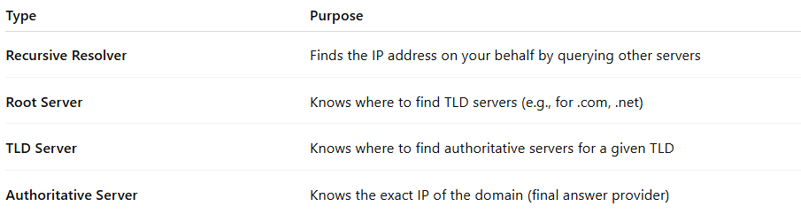

Type | Purpose
Recursive Resolver | Finds the IP address on your behalf by querying other servers
Root Server | Knows where to find TLD servers (e.g., for .com, .net)
TLD Server | Knows where to find authoritative servers for a given TLD
Authoritative Server | Knows the exact IP of the domain (final answer provider)

